Copy deck en

**1. Home 2**

Hero 2

Our Services 2

News 2

Testimonials 4

Support us 4

**2. Become a member 5**

**3. News 6**

**4. 1 News 11**

**5. Services 13**

The Congress 13

Association 13

CCR 13

Tenant on the Board of Directors 13

FLHLMQ Bulletin 14

Newsletter 14

Practical guides 14

Conference notebook 14

Briefs 15

Research 15

**6. Service 16**

**7. Team 17**

**8. About 18**

**9. Contact us 19**

**10. FAQ (Frequently asked questions) 20**

**11. Error 404 21**

# 1. Home

## Hero

Accessibility and Equity

Housing with Dignity

Becoming a Member

## Our Services

Nearly 300 tenant associations and Resident Advisory Committees (RACs) renew their membership in the FLHLMQ each year. It is thanks to you that the federation can speak with a strong voice to the governments of Quebec and Ottawa so that they take care of our housing.

By paying your membership fee to be a member of the FLHLMQ, you allow us to be representative of tenants across Quebec and to stay in touch with you to help you at all times.

Learn more

## News



Petition for quality HLM

September 11, 2024

The FLHLMQ hopes to collect 10,000 signatures.

Read the article

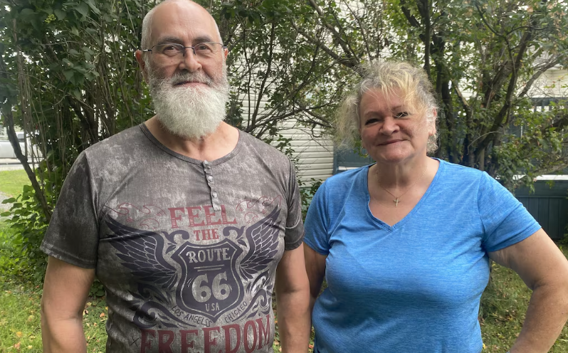

The contempt has gone on long enough!

September 11, 2024

The Office d'habitation du lac Abitibi must change its attitude.

Read the article



First shovel of earth for Unitaînés in Rimouski

September 10, 2024

Offices must not depend on others to fulfill their mission.

Read the article

See more news

## Testimonials

"I managed to find affordable housing for me and my son."

Carole and Simon, Sorel

"I like feeling useful as a member of the FLHLMQ!"

Fabiola, Laval

"Tenant rights education helped me a lot."

Jonathan, Shawinigan

See more testimonials

## Support us

Each donation helps our organization support the community and our members.

Thank you

$5, $20, $50

Make a donation

Learn more

# 2. Become a member

<https://flhlmq.com/fr/publication/adhesion-et-abonnement>

Membership and subscription

Why become a member of the FLHLMQ?

Nearly 300 tenant associations and resident advisory committees (CCR) renew their membership in the FLHLMQ each year. It is thanks to you that the federation can speak with a strong voice to the governments of Quebec and Ottawa so that they take care of our housing. The strength that you give us by being a member of our federation has allowed us in recent years to advance the cause of HLM in several ways:

* Obtaining a rent freeze and free laundry rooms for May to October 2020 due to confinement;
* Increasing the subsidy to tenant associations from $17 to $26;
* Increasing the amount granted to tenants during a mandatory transfer of housing from $400 to $500;
* Reducing rents for families receiving child support;
* Free training sessions available to all tenants in Quebec, online on zoom, every Wednesday.

By paying your membership fee to be a member of the FLHLMQ, you allow us to be representative of tenants across Quebec and to stay in touch with you to help you at all times. In the case of CCRs, you can ask the office to pay your membership fee to the FLHLMQ.

Use this [ form ] to become a member or to renew your membership.

Rates**

* $25 per year for associations and CCRs with 40 or fewer dwellings;
* $50 per year for associations and CCRs with 41 to 100 dwellings.
* $75 per year for associations and CCRs with more than 100 dwellings.

Make a cheque payable to the FLHLMQ and send it with your form to our offices at: FLHLMQ, 2520, av. Lionel-Groulx, office 202, Montreal, QC, H3J 1J8

** It is possible to make arrangements to adjust the amount of the contribution for very small associations, grouping 10 dwellings or less.

# 3. News

<https://www.flhlmq.com/fr/actualit%C3%A9>



Petition for quality low-cost housing

September 11, 2024

The FLHLMQ wants to collect 10,000 signatures.

Learn more



The contempt has gone on long enough!

September 11, 2024

The Office d'habitation du lac Abitibi must change its attitude.

Learn more



First shovel of earth for Unitaînés in Rimouski

September 10, 2024

Offices must not depend on others to fulfill their mission.

Learn more

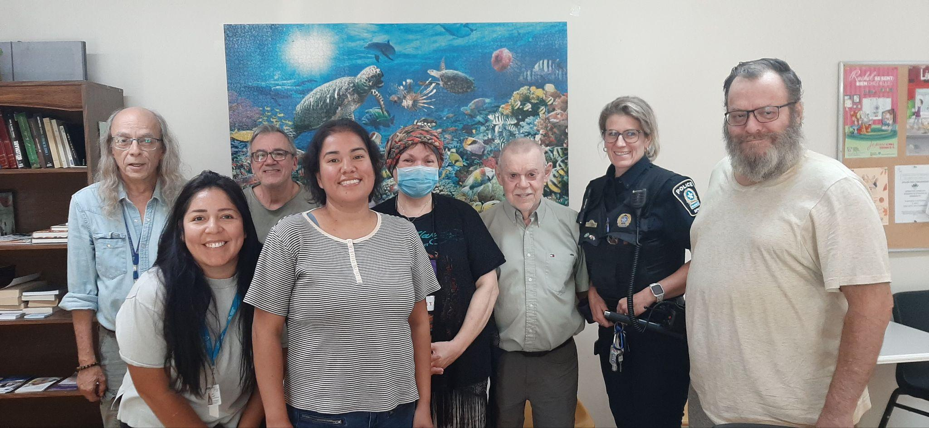

Community safety in a Montreal low-cost housing project

September 5, 2024

Tenants are not alone!

Learn more



Demonstration on September 15 in Quebec City

September 4, 2024

We are marching behind the banner "I want low-cost housing"!

Learn more

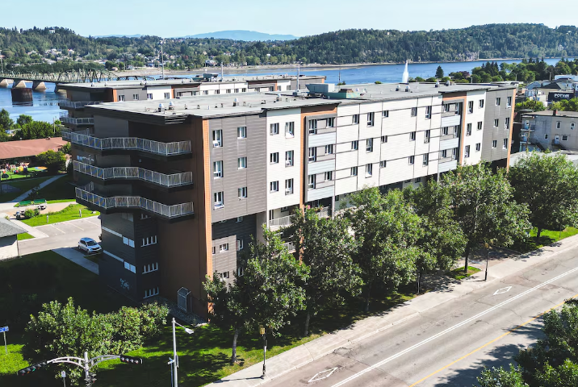

Record demand for low-cost housing in Saguenay

September 3, 2024

The list explodes from 200-300 to 454 people waiting.

Learn more



A new fast track for developers

August 30, 2024

Housing offices must be among them.

Learn more

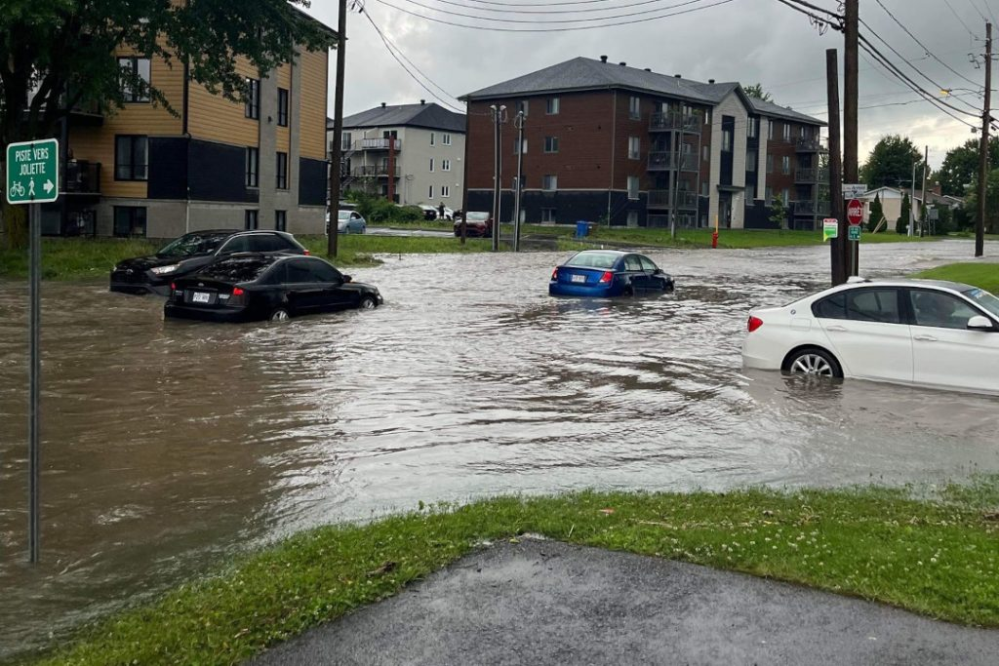

Floods in Lanaudière

August 27, 2024

The SHQ takes care of its tenants.

Learn more

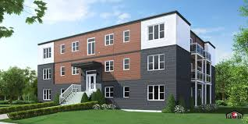

Prefabricated HLM?

August 27, 2024

A golden opportunity for offices.

Learn more



A strategy that limits the number of future social housing units to 4%

August 22, 2024

Low-income household targets.

Learn more

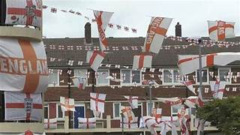

A radical construction plan in England

August 21, 2024

Ten times better than Quebec!

Learn more



Demonstrate in Quebec City on September 14 and 15

August 20, 2024

The FLHLMQ will be there to demand low-cost housing.

Learn more

See more news

# 4. 1 News

<https://www.flhlmq.com/fr/article/petition-pour-des-hlm-de-qualite>

Petition for quality HLM

Submitted by Rédaction on Wed 11/09/2024 - 15:50



The FLHLMQ will take advantage of the demonstration and camp organized by the FRAPRU to demand social housing, on September 14 and 15, to publicly launch its petition for quality HLM. Starting the following week, all our associations and the CCRs of Quebec will be invited to go door-to-door to collect at least 10,000 signatures and ask their MNA to submit them on their behalf to the National Assembly.

The wording of the petition is simple to understand and explain:

WHEREAS the mission of the Société d’habitation du Québec is to provide citizens with low-rent housing;

WHEREAS the 73,000 low-rent housing units (HLM) spread across Quebec are not sufficient to meet the needs of the 34,000 households on the waiting lists;

WHEREAS inflation in recent years has reduced the budget of housing offices by nearly 10% and has significantly affected services to tenants, particularly by worsening the staff shortage;

We, the signatories, call on the Government of Quebec to:

* Implement a new HLM program allowing housing offices to build 5,000 housing units per year;
* Fully index the budgets allocated to the administration and maintenance of HLMs.

If each association submits 10, 20 or 100 signatures, more than 10,000 signatures will be collected across Quebec and dozens of MNAs will submit them to the National Assembly.

The addition of all your petitions will make us strong!

[ Letter Petition web.pdf ]

[ Petition web.pdf ]

Next news

# 5. Services

<https://flhlmq.com/fr/vie-democratique>

<https://flhlmq.com/fr/bulletin-de-la-flhlmq-1>

<https://flhlmq.com/fr/infolettre>

<https://flhlmq.com/fr/guides-pratiques>

## The Congress

The FLHLMQ brings together on a voluntary basis some 300 tenant associations and CCRs that are free and independent. It is important for the FLHLMQ that a demographic life reigns among them.

Learn more

## Association

The association ensures the well-being and improvement of the quality of life of tenants. It is an autonomous organization that decides on its organizational mode and the activities it wants to carry out.

Learn more

## CCR

A Residents' Advisory Committee is a body that allows HLM tenants to participate in the management of their building and to make recommendations to the OMH management on all issues that affect them.

Learn more

## Tenant on the Board of Directors

The SHQ Act provides that the board of directors (CA) of a housing office is composed of a fixed number of directors that can be five to fifteen people.

Learn more

## FLHLMQ Bulletin

The FLHLMQ Bulletin is published two to four times a year and contains a small gold mine of useful information for tenant associations and CCRs.

Learn more

## Newsletter

Subscribe to the newsletter so you don't miss anything! The latest news, activities and new features will be part of it!

[ Subscribe to the 2024 Newsletter! ]

Learn more

## Practical guides

Several practical guides are available to enlighten you on our organization and its operation.

Learn more

## Conference notebook

Each year, the FLHLMQ prepares a notebook for its conference that reflects the issues, work and achievements of the federation. It generally includes a portrait of the board of directors, financial statements and the proposals that will be voted on at the conference. They are therefore the memory of the FLHLMQ.

Learn more

## Briefs

Several briefs and press releases are available to help you.

Learn more

## Research

Study and research documents on HLM in Quebec.

Learn more

# 

# 6. Service

<https://flhlmq.com/fr/vie-democratique>

Democratic life

The FLHLMQ brings together on a voluntary basis some 300 tenant associations and CCRs that are free and independent. A lot of effort is made to ensure a strong and democratic associative life. In addition to the meetings of the federation's board of directors that bring together representatives from all regions of Quebec, there are regular regional meetings that allow exchanges between tenants and/or members of the association boards.

The congress

The congress, which is generally held every June, is a crucial moment in associative life. More than 200 delegates meet there to exchange, vote on the federation's main orientations and elect the board of directors. Each association and CCR can present proposals that are discussed and voted on by the delegates. The work of the federation, particularly that of the CA and the work team, will be structured on the basis of the proposals that were adopted for the coming year.

Each congress also allows for discussions between delegates and certain key government ministers - municipal affairs, employment and solidarity, seniors' secretariat - or representatives of the SHQ.

The regional caucuses take advantage of the congress to choose their representative on the FLHLMQ board of directors.

# 7. Team

<https://flhlmq.com/fr/equipe-de-la-flhlmq>

FLHLMQ Team

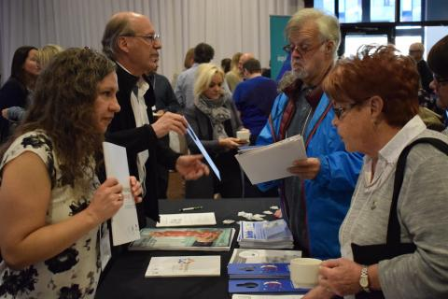

The FLHLMQ office has four employees:

Robert Pilon, Community Organizer - robert.pilon@flhlmq.com

Élisabeth Pham, Administrative Director - elisabeth.pham@flhlmq.com

Patricia Viannay, Coordinator - patricia.viannay@flhlmq.com

Anik Leroux, Community Organizer - anik.leroux@flhlmq.com

# 8. About

<https://flhlmq.com/fr/presentation-de-la-flhlmq>

Presentation of the FLHLMQ

Founded in 1993, the Fédération des locataires d’habitations à louer modique du Québec (FLHLMQ) brings together more than 300 HLM tenant associations and resident advisory committees (CCR) spread across Quebec.

The mission of the FLHLMQ is:

to promote and defend the interests of tenants and work to improve their quality of life;

to provide support to the work carried out locally by tenant associations;

to promote the involvement and support of tenants in HLM;

to represent tenants before political and administrative bodies.

The FLHLMQ is managed by a board of directors of 18 tenants representing the different regions of Quebec. They are elected for two years, at the FLHLMQ convention. Each of them is responsible for the links with the associations and CCRs of their region, in addition to being the organizer of the regional activities of the FLHLMQ.

If you want to know more about the democratic functioning of the FLHLMQ, you can consult our general regulations.

[ GENERAL REGULATIONS OF THE FLHLMQ - 2021.pdf ]

The FLHLMQ employs 4 people: Robert Pilon, Élisabeth Pham, Patricia Viannay and Anik Leroux. The offices of the federation are located in Montreal.

# 9. Contact us

<https://flhlmq.com/fr/nous-joindre>

To contact the Fédération des locataires d’habitations à louer modique du Québec (FLHLMQ).

by phone:

* (514) 521-1485
* 1-(800)566-9662

by fax:

* (514) 521-6444

by mail:

2520, ave. Lionel-Groulx, room 202

Montreal, (Quebec)

H3J 1J8

by email:

info@flhlmq.com

WEB site:

flhlmq.com

on Facebook:

* Robert Pilon

Community organizer

* Patricia Viannay

Coordinator

* Élisabeth Pham

Administrative director

* Anik Leroux

Community organizer

# 10. FAQ (Frequently asked questions)

<https://flhlmq.com/fr/questions-et-reponses>

FAQ

Recently, the president of my office declared a closed session and asked the two tenants to leave while the other members continued the meeting. Did he have the right to ask us to leave?

NO! As a director, you have the right to attend meetings and no one can exclude you (apart from the CEO of the SHQ following an official sanction). The closed session has the effect of requiring confidentiality on the content of a discussion and not of excluding certain directors from the discussion.

In the case of a conflict of interest, "a director must withdraw for the period when the board deliberates and votes" (art. 12). However, the definition of a conflict of interest specified in art. 13 of the Code “does not, however, prevent an elected director from deciding on general measures applicable to tenants” (art. 14). The issue must concern you specifically and uniquely (you and only you) for you to be in a conflict of interest situation.

In my office, a tenant is paid to act as a janitor while she sits as a representative on the board of directors. Is there a conflict of interest?

YES! The tenant cannot be both the employer of the director of the office by sitting on the board of directors and at the same time be an employee of this person. This is a situation that puts her personal interest in conflict with that of the office (art. 13). The tenant must choose one position or the other, but not both.

Can a tenant convicted by the Régie du logement for non-payment sit on the board of directors of the office?

NO! The administrator is appointed to contribute to the proper administration of the property for which he is responsible and he "must organize his personal affairs in such a way that they cannot harm the exercise of his functions" (art. 4). In such a case, he must resign because he is no longer authorized to sit. Failing this, the other members of the CA can ask the tenants who elected him to dismiss him or the CEO of the SHQ to dismiss him.

# 11. Error 404

Error 404

The page you are looking for can’t be found.